Untitled

Mehrab Atighi

4/7/2021

library(CircStats)

## Warning: package 'CircStats' was built under R version 4.0.5

## Loading required package: MASS

## Loading required package: boot

#example 1.8:  
t<-c(711.5,1051,6303.9,1883.6,6054.3,6853.7,7201.9,279.8,2311.1,7.5,5296.6,848.2,9068.5,10609.7,592.1,1657.2,5637.9,2951.2,1425.5,121.5)  
#q-qplot first method:  
sample.quantiles.exp<-sort(t)  
i<-1:length(t)  
E<--log(1-(i/(length(t)+1)))  
theoretical.quantiles.exp=E  
fit<-lm(sort(t)~E)  
plot(E,sort(t),col="Orange",xlab = "Ei",ylab="ti")  
abline(fit,col="Brown")

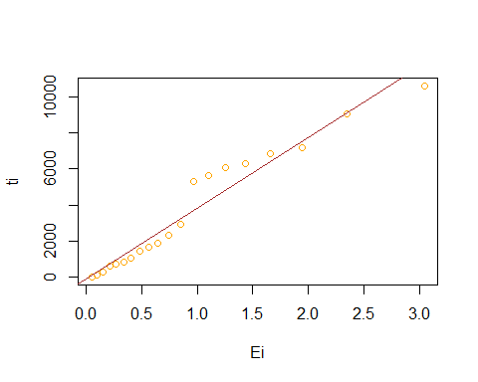

fit$coefficients

## (Intercept) E   
## -103.0802 3930.4210

lamba.hat=1/fit$coefficients[2];theta.hat=fit$coefficients[1]  
print(paste("theta.hat is equal to ",theta.hat,  
 "the lambda.hat is equal to",lamba.hat))

## [1] "theta.hat is equal to -103.080151605163 the lambda.hat is equal to 0.000254425669078671"

# q-qplot second method:  
qqnorm(t,col="Orange")  
qqline(t,col="brown")

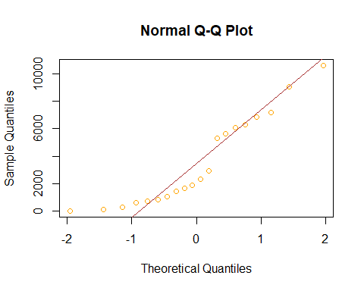

# p-pplot :  
pp.plot(t,ref.line = TRUE)

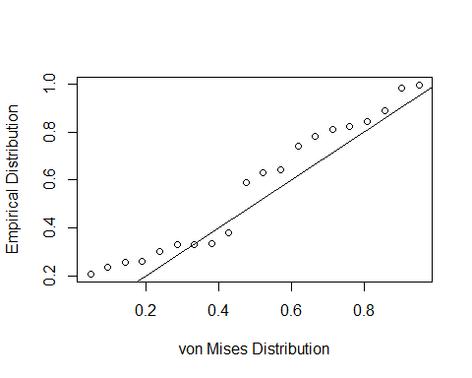

## mu kappa  
## 1 1.688506 0.186204

#example 2.8:  
library("fitdistrplus","qualityTools")

## Warning: package 'fitdistrplus' was built under R version 4.0.4

## Loading required package: survival

##   
## Attaching package: 'survival'

## The following object is masked from 'package:boot':  
##   
## aml

x<-(c(5.77,5.03,4.5,4.1,3.3,3.0,2.5,1.76,1.54,1.33,1.32,1,0.88,0.5,0.22))  
#q-qplot first method:  
i<-1:length(x)  
W<-log(-log(1-(i/(length(x)+1))))  
plot(W,log(sort(x)),col="Orange",xlab="Wi",ylab="Ln(ti)")  
fit1<-lm(log(sort(x))~W)  
abline(fit1,col="Brown")

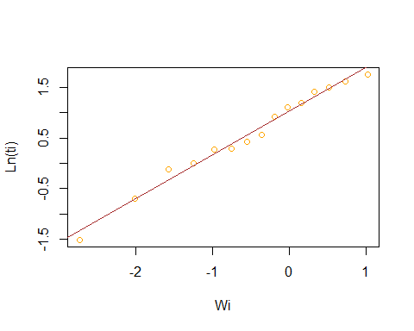

fit1$coefficients

## (Intercept) W   
## 1.0233689 0.8623622

lamba=exp(-fit1$coefficients[1]);Betha.hat=1/fit1$coefficients[1]  
print(paste("betha.hat is equal to ",Betha.hat,  
 "the lambda is equal to",lamba))

## [1] "betha.hat is equal to 0.977164714202085 the lambda is equal to 0.359382168030245"

# q-qplot second method:  
qqnorm(x,col="Orange")  
qqline(x,col="brown")

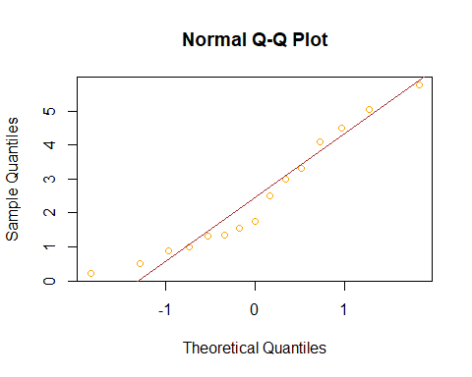

# p-pplot:  
pp.plot(x,ref.line = TRUE)

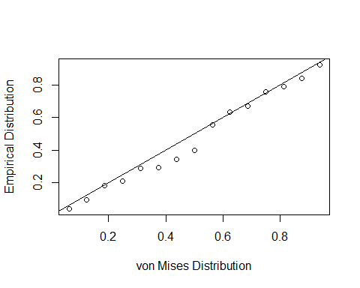

## mu kappa  
## 1 1.303468 0.510308

#example 3.8:  
t<-c(17.88,28.92,33.00,41.52,41.12,45.60,48.40,51.84,51.95,54.12,55.56,67,80,68.64,68.64,84.12,93.12,98.64,105.12,127.92,128.04,173.40)  
#q-qplot first method:  
i<-1:length(t)  
Zi<-qnorm(i/(length(t)+1))  
plot(log(sort(t)),Zi,xlab = "Ln(ti)",ylab= "Zi",col="Orange")  
fit<-lm(Zi~log(sort(t)))  
abline(fit,col="brown")

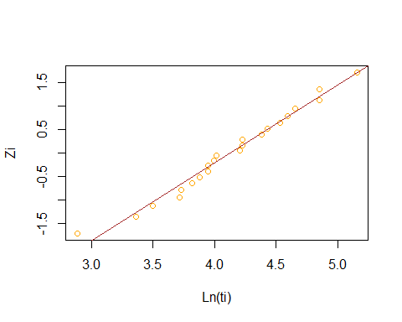

fit$coefficients

## (Intercept) log(sort(t))   
## -6.842195 1.655786

mu.hat<-fit$coefficients[1];sigma.hat<-fit$coefficients[2]  
print(paste("the mu.hat is equal to",mu.hat,  
 "the sigma.hat is equal to",sigma.hat))

## [1] "the mu.hat is equal to -6.84219457592908 the sigma.hat is equal to 1.65578644318971"

# q-qplot second method:  
qqnorm(t,col="Orange")  
qqline(t,col="brown")

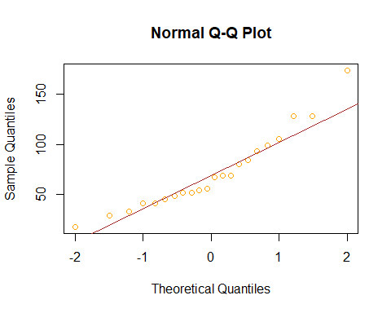

#p-pplot :  
pp.plot(t,ref.line = TRUE)

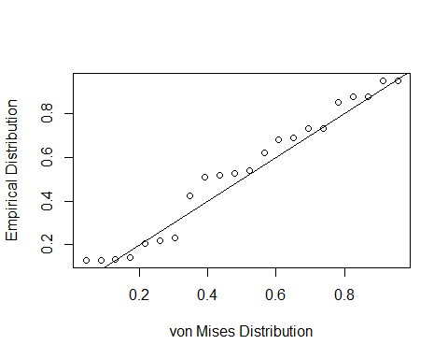

## mu kappa  
## 1 3.971496 0.6268875

End.